Day in the Life of the Hudson River 10/13/22
Dobbs Ferry Waterfront, Dobbs Ferry, NY
RIVER MILE: 23
Salt Front: ~ RM 76
EF Academy & Bio Boat (11th and 12th grade)– Stephen Fleming
140 students & 7 adults
Latitude 41.01516 N & Longitude – 73.87999 W

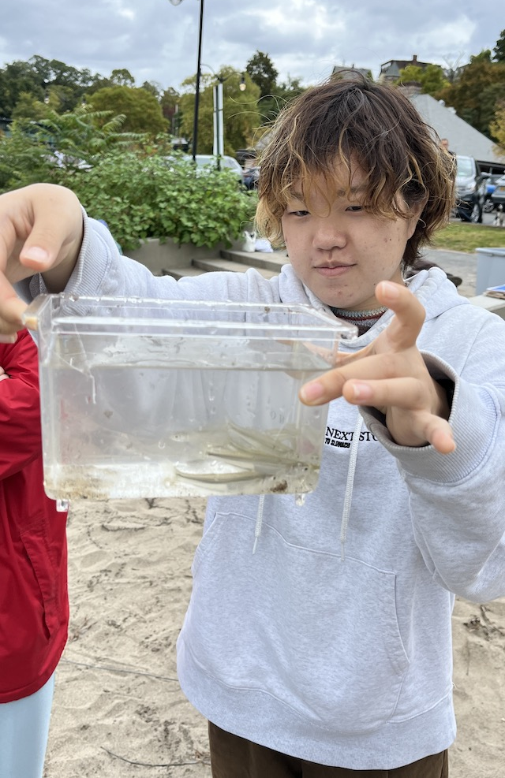
Location: Dobbs Ferry Waterfront, Dobbs Ferry, NY
Area: Beach Front, docks, rock shoreline
Surrounding Land Use: Beach
Sampling Site: Beach, RipRap
Shoreline: 50% Sandy and 50% Rocky
Water: Calm
Plants in area: No plants in the water
River Bottom: Muddy and Sandy
*NR = Not read/recorded

ITEM |  | Time |  | Reading |  |  |  | Comments
Physical
Air Temperature |  | 10:51 AM  11:08 AM  11:27 AM |  | 21.5° C  21.5° C  22.5° C |  |  | 70.7°F  70.7°F  72.5°F
Wind Speed: |  | 11:00 AM |  | Anemometer  2 m/s |  |  | Beaufort  NR | Direction  S
Weather today |  | 11:00 AM |  | > 75% cloud cover |  |  | Drizzle
Weather the past 3 days: |  | Warm and sunny, cool nights
Tides- |  | Time |  | Rising, Falling, Unchanged |  |  | Water Height (cm)
 |  | 11:00 AM  11:20 AM  11:30 AM |  | Rising  Rising  Rising |  |  | 50 cm  58 cm  64 cm
Current- |  | Time |  | Cm/sec |  | Knots | North/South | Ebb/Flood/Still
 |  | 11:00 AM  11:10 AM  11:20 AM |  | 33.5  35.3  30.6 |  | NR | NR | Ebb
Water Temperature- |  | 11:00 AM  1:52 PM  2:37 PM |  | 18.5°C  17.5 °C  17.8 °C |  |  | 65.3°F  63.5 °F  64.04°F
Turbidity- Long Sight Tube (120 cm) |  | 11:00 AM |  | 37 cm  40.5 cm  35.5 cm |  |  | Average 37.7 cm
Chemical
Salinity- Refractometer |  | 11:00 AM |  | 10 ppt
Standardized Salinity – |  | NR
DO – Lamotte |  | Time  11:05 AM |  | Temp  18.5°C |  |  | ppm DO  12 ppm | % saturation  130%
pH – Color Match Kit |  | 11:08 AM  2:04 PM  2:27 PM |  | 6.5  7.0 /7.4  6.5/5.5 |  |  |  | Average 7.2  Average 6.0
Nitrates- |  | 10:18 AM |  | 2.5 mg/L
Phosphates- NR
Alkalinity- NR
Biological
Fish – Seine |  | Number |  | Name |  |  | Length of longest | Length of smallest
10:00 -11:00 AM |  | 34  15  1 |  | Atlantic Silverside  Striped Bass  Hogchoker |  |  | 8.5 cm  13 cm  5 cm | 3 cm  4 cm
Fish Totals |  | TOTAL: 50 |  | Diversity: 3
Macroinvertebrates |  | Number |  | Name |  |  | Length of longest | Length of smallest
 |  | 1 |  | Blue Crab (F) |  |  | 4 cm
Macroinvertebrate Totals |  | TOTAL:1 |  | Diversity: 1
Sediment Core - NA
Length | H2S smell |  | Oxid Top |  | Oil |  | Grain Size | Other Features
Boats-NR
 | Time |  | Name |  | Color |  | North/Southbound | Light/Loaded

